**ECE 7810 ASSIGNMENT REPORT**

**(Solution of Fields by Num. Mtds I)**

**Author:** Jamiu Babatunde Mojolagbe

**Department:** Electrical and Computer Engineering

**Student ID:** #7804719

**Email:** mojolagm@myumanitoba.ca

**Course:** ECE 7810

**Homework:** 4

**Sub. Date:** November 12, 2016

**REPORTS**

The code given was studied and modified to use square grid. It was used to test different cases as it was all included in the code.

The dielectric used in the code are written as functions. Each function name corresponding to a particular type of object/dielectric; though, the named used were arbitrary such as ‘**object1.m**’ for cylindrical cell and ‘**object5.m**’ refers to square grid – as used for this homework.

The ‘object5’ used here, for square dielectric, has four (4) parameters to be supplied to the function. These input parameters are:

‘a’ => half thickness

‘b’ => half width

‘d’ => area of the grid

‘l’ => cell size

And the function returns the grid details of the dielectric type to be used.

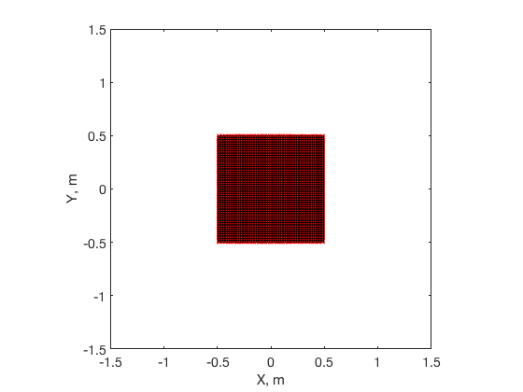When the ‘object5’ was used and necessary parameters of the square dielectric were uncommented, because all the details are already included in the code, the following graphs were obtained:

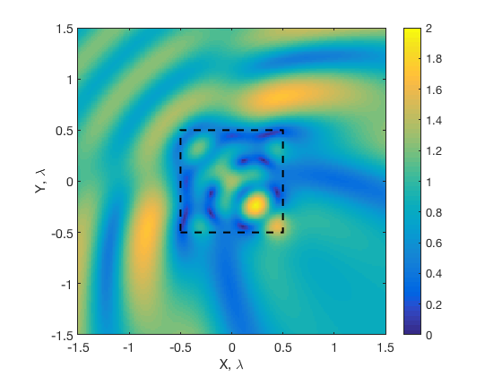

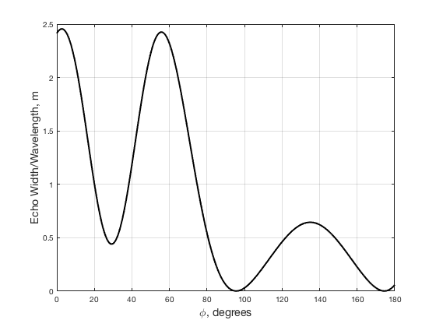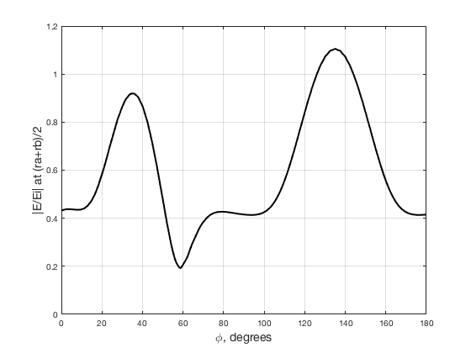

Note: As it was discussed in class to find the bug in the code, unfortunately, I was not able to find the bug in the code.